**Institute of Engineering & Technology**

**Devi Ahilya Vishwavidyalaya, Indore**

**Department of Computer Science & Engineering**



**Object Oriented Programming (CER3C2)**

**Assignment-5**

**(String)**

**Submitted To: Submitted By:**

**Harshita Sharma Mam Tanishq Chauhan (21C3184)**

**CS-Dept CS “B” 2nd Year**

**IET-DAVV**

**Assignment-5**

1. Write a Java Program that does following:
2. Declare a String Object named s containing the string “Help me God.”
3. Print the entire String.
4. Use the length( ) method to print the length of the String.
5. Use the charAt( ) method to print the first character in the String.
6. Use the indexOf( ) and the substring( ) methods to print the first word in the String.
7. Count and print all the duplicates string.

import java.util.*;

public class StringOp {

    public static void main(String[] args) {

        String s = "Help me God";

        System.out.println(s);

        System.out.println(s.length());

        System.out.println(s.charAt(0));

        System.out.println(s.indexOf("me"));

        System.out.println(s.substring(0,3));

        int count=0, ctr=0;

        char[] p = s.toCharArray();

        for(int i=0; i<s.length(); i++)

        {

            count = 1;

            for(int j=i+1; j<s.length(); j++)

            {

                if(s.charAt(i) == s.charAt(j))

                {

                    count++;

                    p[j] = '0';

                }

            }

            if(count>1 && s.charAt(i)!='0')

            {

                ctr++;

                System.out.print(p[i] + " ");

            }

        }

        System.out.print("Number of Dublicates: " + ctr);

        System.out.println();

    }

}

**Output**

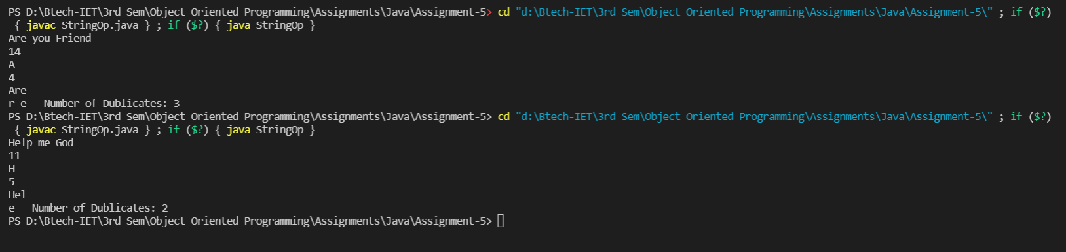

1. Write a java program that capitalizes first letters of each word in the String. (for example “this Is pEn” would generate the output “This Is A Pen”).

import java.util.*;

public class Capital {

    public static void main(String[] args) {

        String s;

        Scanner sc = new Scanner(System.in);

        System.out.print("Enter a String: ");

        s = sc.nextLine();

        char[] c;

        String e = s.toLowerCase();

        c = e.toCharArray();

        c[0] = Character.toUpperCase(c[0]);

        for(int i=0; i<s.length(); i++)

        {

            if(s.charAt(i)==32)

            {

                c[i+1] = Character.toUpperCase(c[i+1]);

            }

        }

        for(int i=0; i<s.length(); i++)

        {

            System.out.print(c[i]);

        }

        sc.close();

    }

}

**Output**

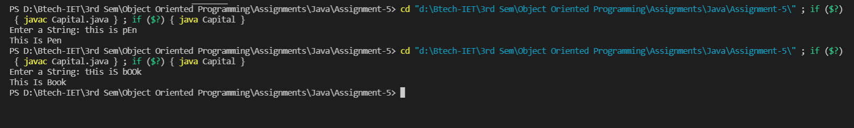

1. Write a java program that inputs five names and then prints them in their increasing alphabetical order.

import java.util.*;

public class IncreaseAlpha_order {

    public static void main(String[] args) {

        Scanner sc = new Scanner(System.in);

        String[] s = new String[5];

        for(int i=0; i<5; i++)

        {

            System.out.print("Enter the "+ (i+1) + "th Word:");

            s[i] = sc.nextLine();

        }

        Arrays.sort(s);

        System.out.println();

        System.out.println("The Words in Increasing Order: ");

        for(int i=0; i<5; i++)

        {

            System.out.print(s[i] + " ");

        }

        sc.close();

    }

}

**Output**

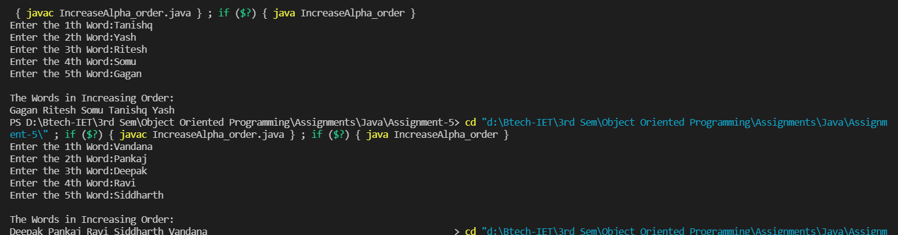

1. Write a java program that inputs the name of the month and does following:
2. Echoing the input.
3. Extracting the first three letters of the input (printing the abbreviation) in capital.
4. Using switch statement to identify and print the number of the month from the abbreviation.
5. Print the number of days of month.

import java.util.*;

public class Month {

    public static void main(String[] args) {

        Scanner sc = new Scanner(System.in);

        System.out.println();

        System.out.print("Enter the Name of the Month:");

        String ech = sc.nextLine();

        System.out.println();

        System.out.println("Echoing the Input: " + ech);

        String mon = ech.substring(0,3);

        mon = mon.toUpperCase();

        System.out.println(mon);

        switch(mon)

        {

            case "JAN" :

            System.out.println("1st Month of the Calendar");

            System.out.println("The Number of Days in Month is: 31");

            break;

            case "FEB" :

            System.out.println("2nd Month of the Calendar");

            System.out.println("The Number of Days in Month is: 28/29");

            break;

            case "MAR" :

            System.out.println("3rd Month of the Calendar");

            System.out.println("The Number of Days in Month is: 31");

            break;

            case "APR" :

            System.out.println("4th Month of the Calendar");

            System.out.println("The Number of Days in Month is: 30");

            break;

            case "MAY" :

            System.out.println("5th Month of the Calendar");

            System.out.println("The Number of Days in Month is: 31");

            break;

            case "JUN" :

            System.out.println("6th Month of the Calendar");

            System.out.println("The Number of Days in Month is: 30");

            break;

            case "JUL" :

            System.out.println("7th Month of the Calendar");

            System.out.println("The Number of Days in Month is: 31");

            break;

            case "AUG" :

            System.out.println("8th Month of the Calendar");

            System.out.println("The Number of Days in Month is: 31");

            break;

            case "SEP" :

            System.out.println("9th Month of the Calendar");

            System.out.println("The Number of Days in Month is: 30");

            break;

            case "OCT" :

            System.out.println("10th Month of the Calendar");

            System.out.println("The Number of Days in Month is: 31");

            break;

            case "NOV" :

            System.out.println("11th Month of the Calendar");

            System.out.println("The Number of Days in Month is: 30");

            break;

            case "DEC" :

            System.out.println("12th Month of the Calendar");

            System.out.println("The Number of Days in Month is: 31");

            break;

            default:

            System.out.println("Enter Valid Input");

            break;

        }

        sc.close();

    }

}

**Output**

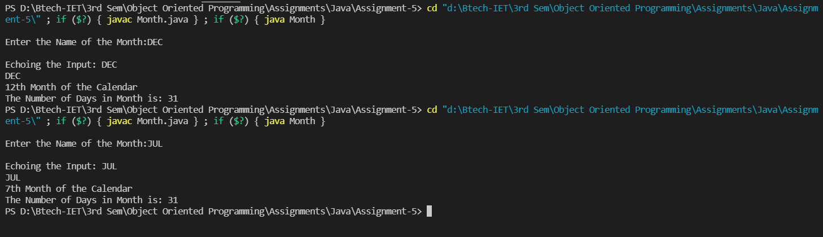

1. Write a Java program to find all interleavings of given strings.

import java.util.*;

import java.util.HashSet;

import java.util.Set;

public class Interleavings {

    public static void allInterleavings(String res, String F, String S, Set < String > out)

    {

        if(F.length() == 0 && S.length() == 0)

        {

            out.add(res);

            return;

        }

        if(F.length() > 0)

        {

            allInterleavings(res + F.charAt(0), F.substring(1), S, out);

        }

        if(S.length() > 0)

        {

            allInterleavings(res + S.charAt(0), F, S.substring(1), out);

        }

    }

    public static void main(String[] args)

    {

        Scanner sc = new Scanner(System.in);

        System.out.print("Enter First String: ");

        String F = sc.nextLine();

        System.out.print("Enter Second String: ");

        String S = sc.nextLine();

        System.out.println("The Given Strings are: " + F + " " + S + "\n");

        System.out.println("The Interleavings Strings are: ");

        Set < String > out = new HashSet < > ();

        allInterleavings("", F, S, out);

        out.stream().forEach(System.out::println);

    }

}

**Output**

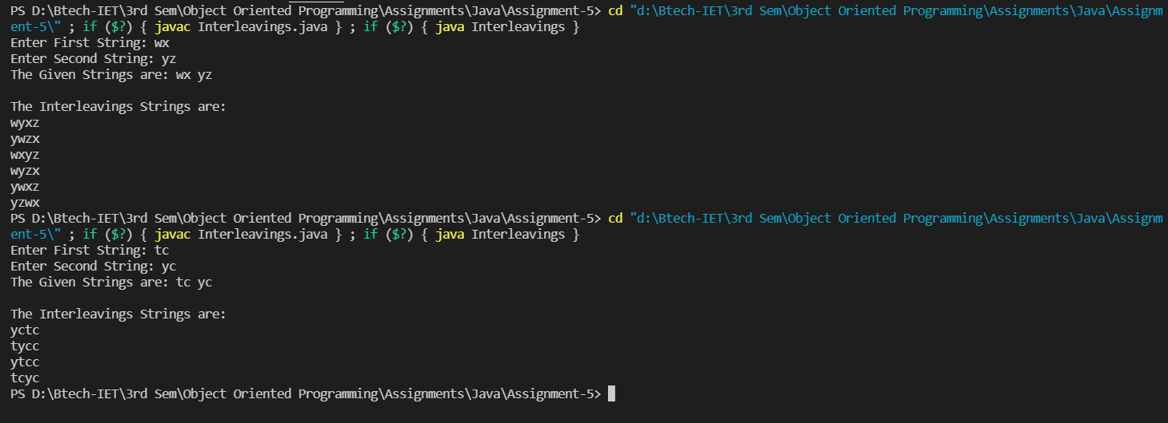

1. Write a Java program to find the second most frequent character in a given string.

import java.util.*;

public class FrequentChar {

    public static void main(String[] args) {

        int max=0, newmax=0;

        String s;

        char p[], k=' ';

        Scanner sc = new Scanner(System.in);

        System.out.print("Enter the String: ");

        s = sc.nextLine();

        s = s.toLowerCase();

        p = s.toCharArray();

        Map<Character, Integer>mp = new HashMap<Character,Integer>();

        for(int i=0; i<s.length(); i++)

        {

            if(mp.containsKey(p[i]) && p[i] != ' ')

            {

                mp.put(p[i], mp.get(p[i]) + 1);

            }

            else{

                if(p[i] != ' ')

                {

                    mp.put(p[i], 1);

                }

            }

        }

        for(char i : mp.keySet())

        {

            if(mp.get(i)>max)

            {

                max = mp.get(i);

            }

        }

        for(char i : mp.keySet())

        {

            if(mp.get(i)<max && mp.get(i)>=newmax)

            {

                k = i;

                newmax = mp.get(i);

            }

        }

        System.out.println("Second Most Frequent Character is: ");

        for(char i : mp.keySet())

        {

            if(mp.get(i) == mp.get(k))

            {

                System.out.print(i + " ");

            }

        }

        sc.close();

    }

}

**Output**

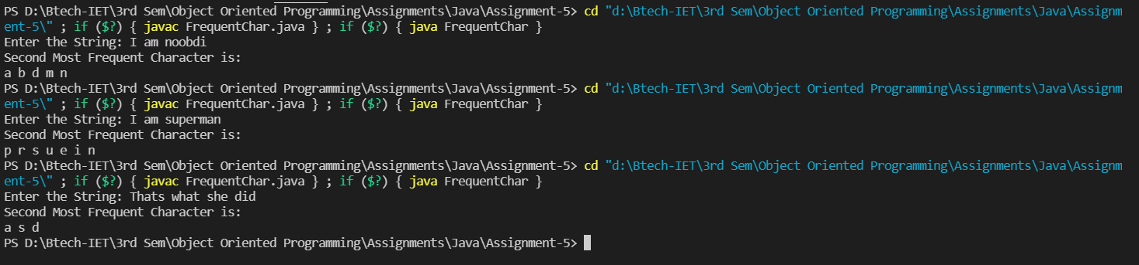

1. Write a Java program to find first non-repeating character from a stream of characters.

import java.util.*;

public class NonRepeating_Char {

    public static void main(String[] args)

    {

        Scanner sc = new Scanner(System.in);

        System.out.print("Enter a String: ");

        String s;

        s = sc.nextLine();

        sc.close();

        s = s.toLowerCase();

        char[] p = s.toCharArray();

        Map<Character, Integer> mp = new HashMap<Character, Integer>();

        for(int i=0; i<s.length(); i++)

        {

            if(mp.containsKey(p[i]))

            {

                mp.put(p[i], mp.get(p[i]) + 1);

            }

            else

            {

                mp.put(p[i], 1);

            }

        }

        int j;

        for(j=0; j<s.length(); j++)

        {

            if(mp.get(p[j])==1 && p[j]!=32)

            {

                System.out.print("The First Non Repeating Character is: " + p[j]);

                break;

            }

        }

        if(j == s.length())

        {

            System.out.println("No Non Repeating Character");

        }

    }

}

**Output**

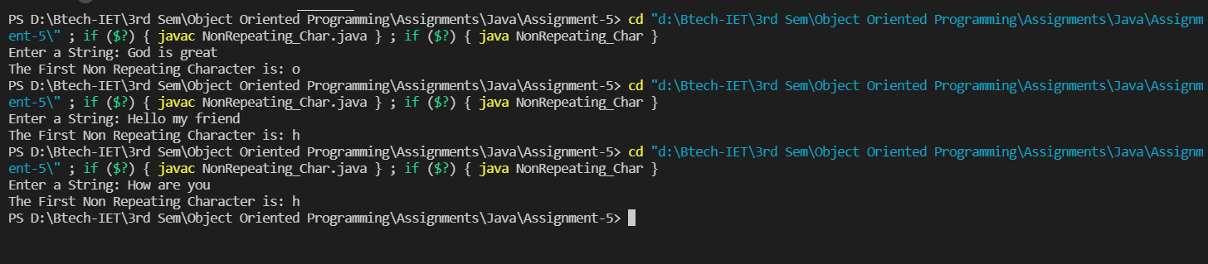

1. Write a Java program to read two strings append them together and return the result. If the strings are different lengths, remove characters from the beginning of longer string and make them equal length.

import java.util.*;

public class Append {

    public static void main(String[] args) {

        Scanner sc = new Scanner(System.in);

        System.out.print("Enter the First String: ");

        String s1 = sc.nextLine();

        System.out.print("Enter the Second String: ");

        String s2 = sc.nextLine();

        sc.close();

        int l1 = s1.length();

        int l2 = s2.length();

        if(l1==l2)

        {

            System.out.println(s1.concat(s2));

        }

        else if(l1>l2)

        {

            System.out.println(s1.substring(l1-l2).concat(s2));

        }

        else

        {

            System.out.println(s1.concat(s2.substring(l2-l1)));

        }

    }

}

**Output**

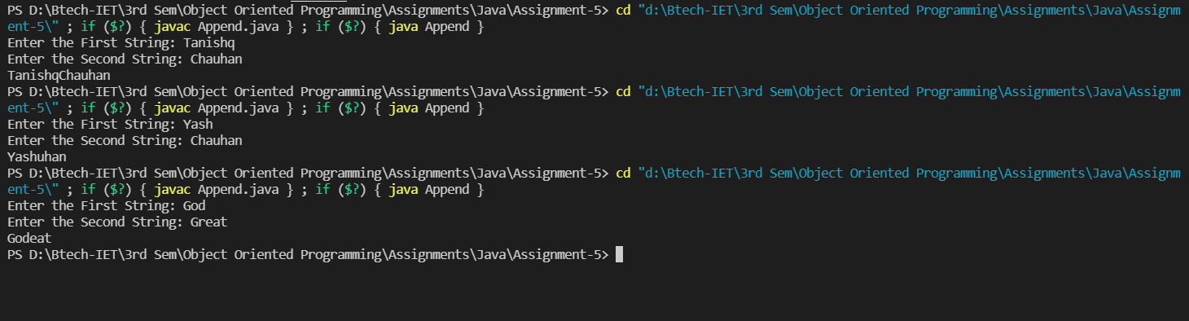

1. Write a Java program to return the sum of the digits present in the given string. If there is no digits the sum return is 0.

import java.util.*;

public class SumDigit {

    public static void main(String[] args) {

        Scanner sc = new Scanner(System.in);

        System.out.print("Enter a String: ");

        String s = sc.nextLine();

        char p[] = s.toCharArray();

        sc.close();

        int sum=0;

        for(int i=0; i<s.length(); i++)

        {

            if(p[i]>48 && p[i]<=57)

            {

                sum = sum + p[i]-48;            }

        }

        System.out.println("The Sum of the Digits is: " + sum);

    }

}

**Output**

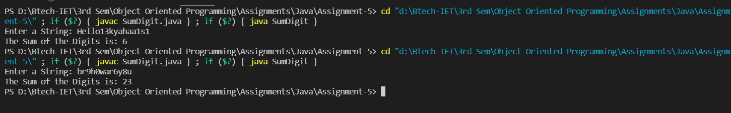

10.Write a Java program to test if a given string contains only digits.

import java.util.*;

public class OnlyDigits {

    public static void main(String[] args) {

        Scanner sc = new Scanner(System.in);

        System.out.print("Enter a String: ");

        String s = sc.nextLine();

        char p[] = s.toCharArray();

        sc.close();

        int count=0;

        for(int i=0; i<s.length(); i++)

        {

            if(p[i]>=48 && p[i]<=57)

            {

                count++;

            }

        }

        if(count == s.length())

        {

            System.out.println("The String Contains Only Digits");

        }

        else if(count == 0)

        {

            System.out.println("The String Does Not Contain Digits");

        }

        else

        {

            System.out.println("The String Does Not Exclusively Contain Digits");

        }

    }

}

**Output**

